Create and

Manage Lists

This lesson describes using lists in Cortex, the steps for creating a list, and the various options for managing a list.

Introduction to Lists in Cortex
A list in Cortex is a container for storing data and is mainly used in playbooks and scripts. Lists can be accessed anywhere the context button (double-curly brackets) appears. In a playbook task, you can access the data in a list via the context button under Lists or by using the path ${lists.<list_name>}. Different types of data can be stored in a list, including text, string, numbers, Markdown, HTML, CSS, and JSON objects.

Common List Examples
The following are common examples of when to use lists in Cortex:
- 
- Allow and Block Lists
- Create a list of IP addresses, URLs, domains, and hashes that can be either allowed or blocked.
- 
- Input for Scripts and Playbooks
- Use the content of a list as input for scripts and playbook tasks.
- 
- Import External Data into Lists
- Import data such as threat feeds into a list that can then be used to identify indicators of compromise (IOCs) in an case investigation.
- 
- Defining HTML Templates
- An HTML template can be defined as part of a communication task.
- 
- Prioritizing Case Response
- Create lists to identify critical assets like important users or servers. This helps manage cases better by focusing on the most important things first.

Creating a New List
Cortex provides the interface to create and manage lists. You can specify the content type and permissions when creating a list.
You can create lists in the Lists menu found at Settings > Configurations > Object Setup > Lists. Click the arrows for more information about creating a list. Click the images to enlarge them.

Step One
- Navigate to Settings > Configurations > Object Setup > Lists, then click + Add a List located at the right corner of the page.
- 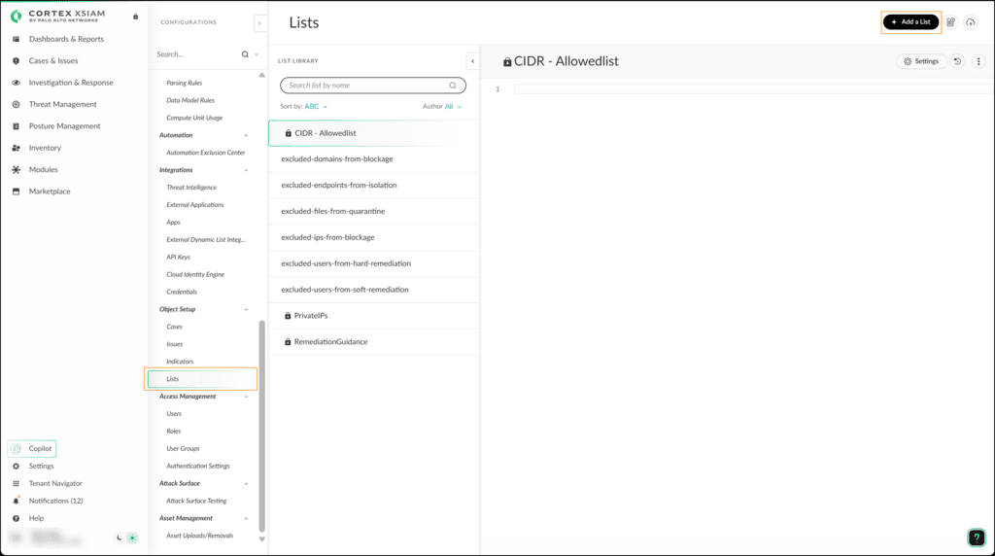

Step Two
- Enter the list name and select the content type from the drop-down menu.
- 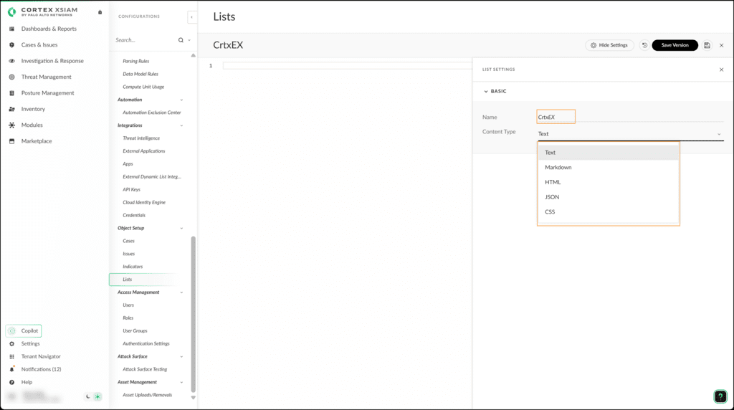

Step Three
- Enter or copy the desired list of items on the left side of the page under the list name. Then click the save icon at the top right of the page.
- 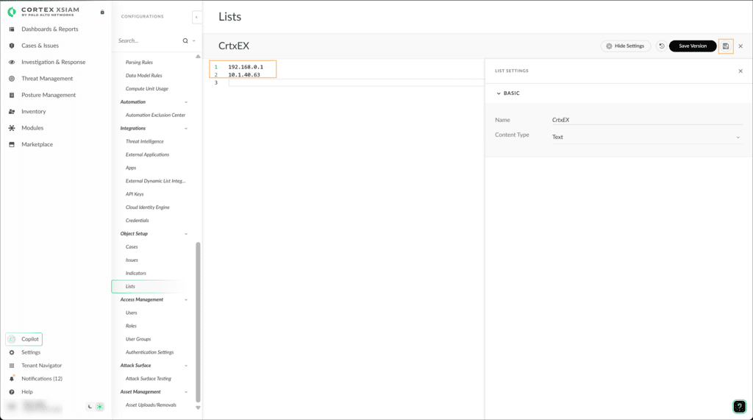

List Page Options
To manage lists, use the following options available on the Lists page. Click the images to enlarge them.

Add a New List, View the Version History of All Lists, or Import a



List Commands and

Playbook Tasks

This lesson provides an overview of the different commands available for managing lists and describes their usage in playbook tasks.

List Management Commands

You can manage lists in Cortex using various commands through the built-in CLI, automation, and playbook tasks. The CLI feature is located at the bottom of the War Rooms interface. It allows you to execute commands and scripts and has a variety of list manipulation commands.

Click the arrows for more information about performing tasks using the CLI list commands. Click the images to enlarge them.

Create a List

Use the createList command to create a new list with a name and list data.

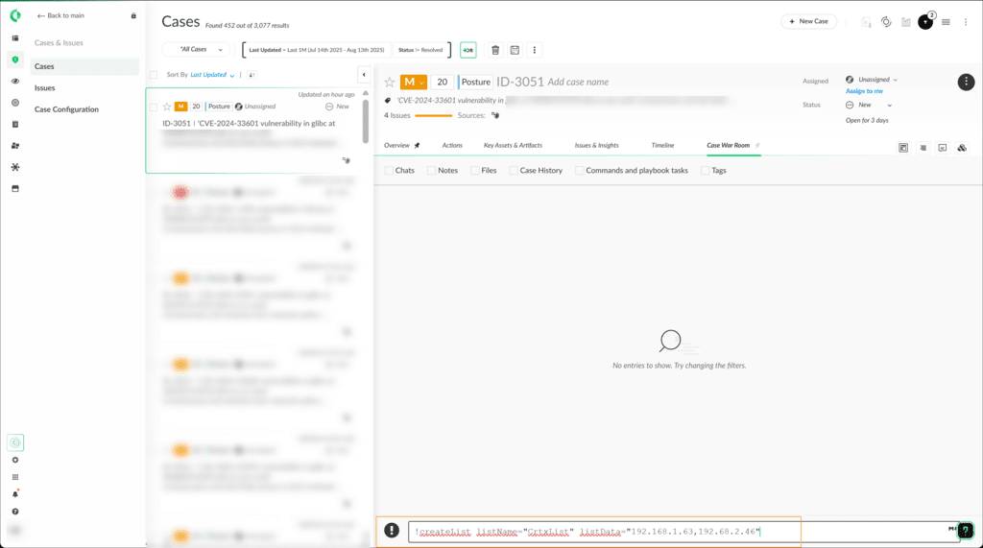

Extracting List Data

Use the getList command along with the listName argument to get the content of the specified list.

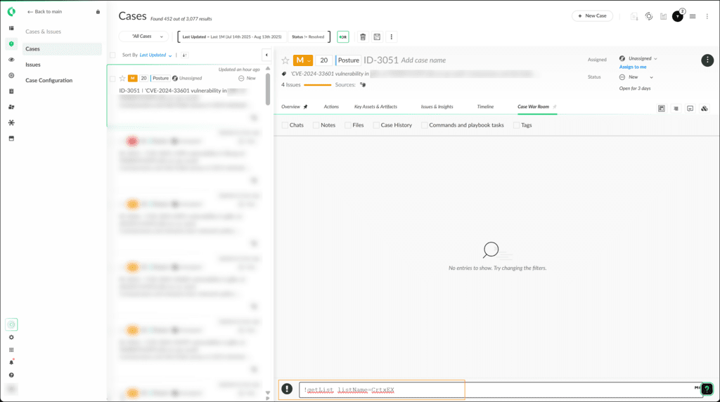

Remove List Item

Use the removeFromList command along with listName and listData arguments to remove an item from a list.

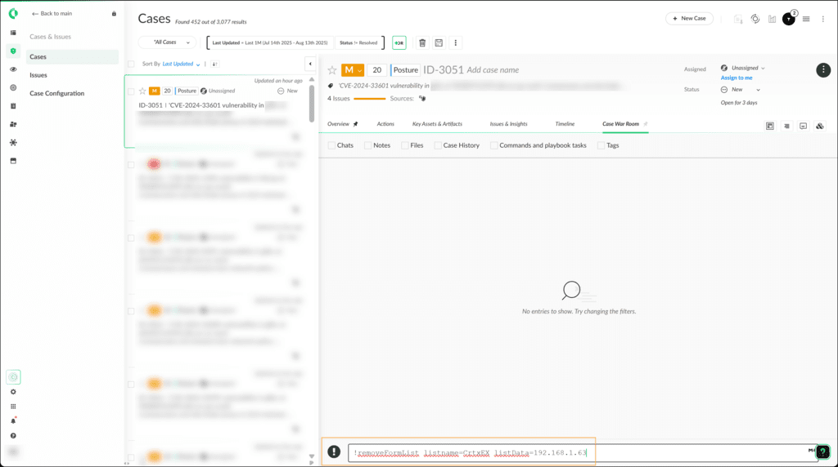

Overwrite Existing List

Use the setList command along with listName and listData arguments to overwrite items to a specified list.

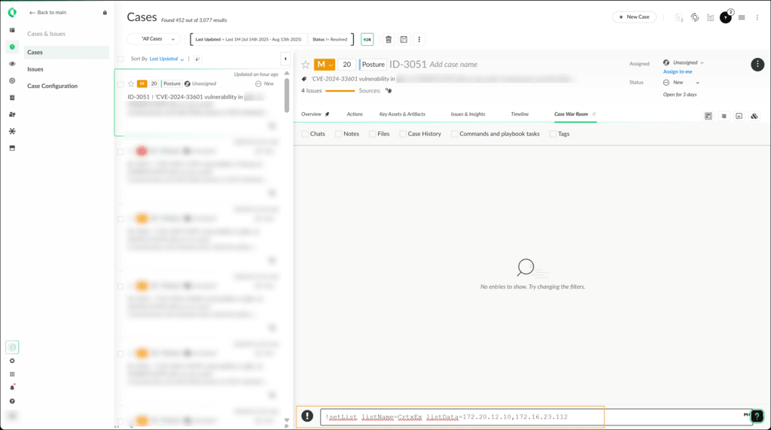

Add Item to a List

Use the addToList command to append single or multiple items to a specified list.

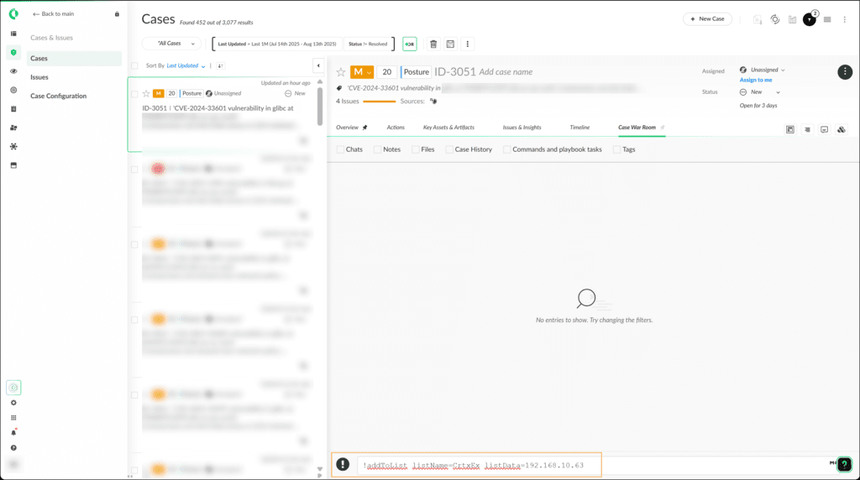

Managing a List Using a Playbook

In Cortex, playbook tasks allow you to automate managing lists. You can use playbook tasks to create, view, and manipulate lists.

Demo: Creating and Viewing a List

Watch this demonstration on creating a new list and displaying its content using playbook tasks.

Elapsed time

0:00/

Total

2:18

Demo: Adding and Removing List Items

Watch this demonstration on adding new items to a list and removing an item from a list using playbook tasks.

Elapsed time

0:00/

Total

3:11

Course Summary

Now that you've completed this course, you should be able to:



Describe the role and importance of lists

Create, organize, and manage lists

Utilize lists to enhance and automate playbook workflows

Use the command-line-interface (CLI) to manage lists

List
Use the + Add a List button to add a new list.
Use the page timer icon next to the + Add a List button to view the version history of all lists.
Use the cloud icon at the top right of the page to import list items from a local file.
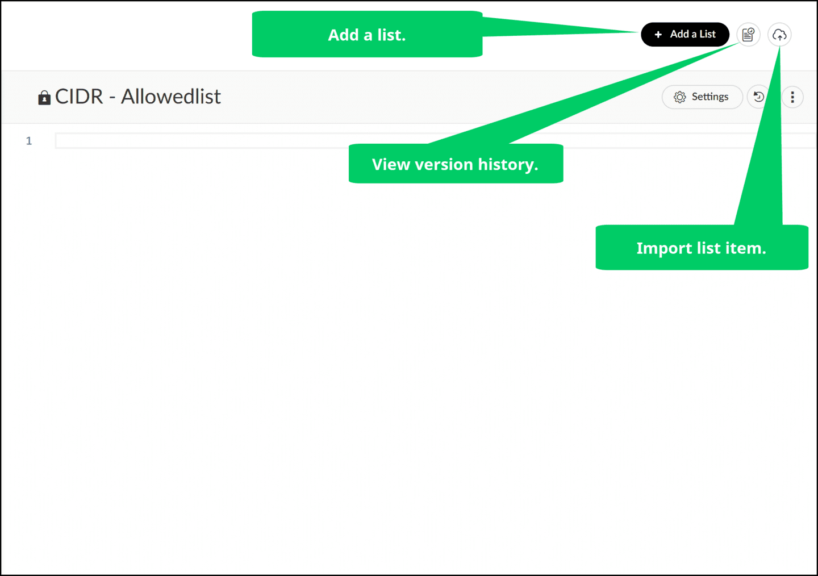

View Settings, Version History, or Edit a List
To view the settings of the list, click the Settings button.
To revert to a previously saved version of the selected list, click the time arrow icon.
To make changes to the content and the settings of the selected list, click Edit.
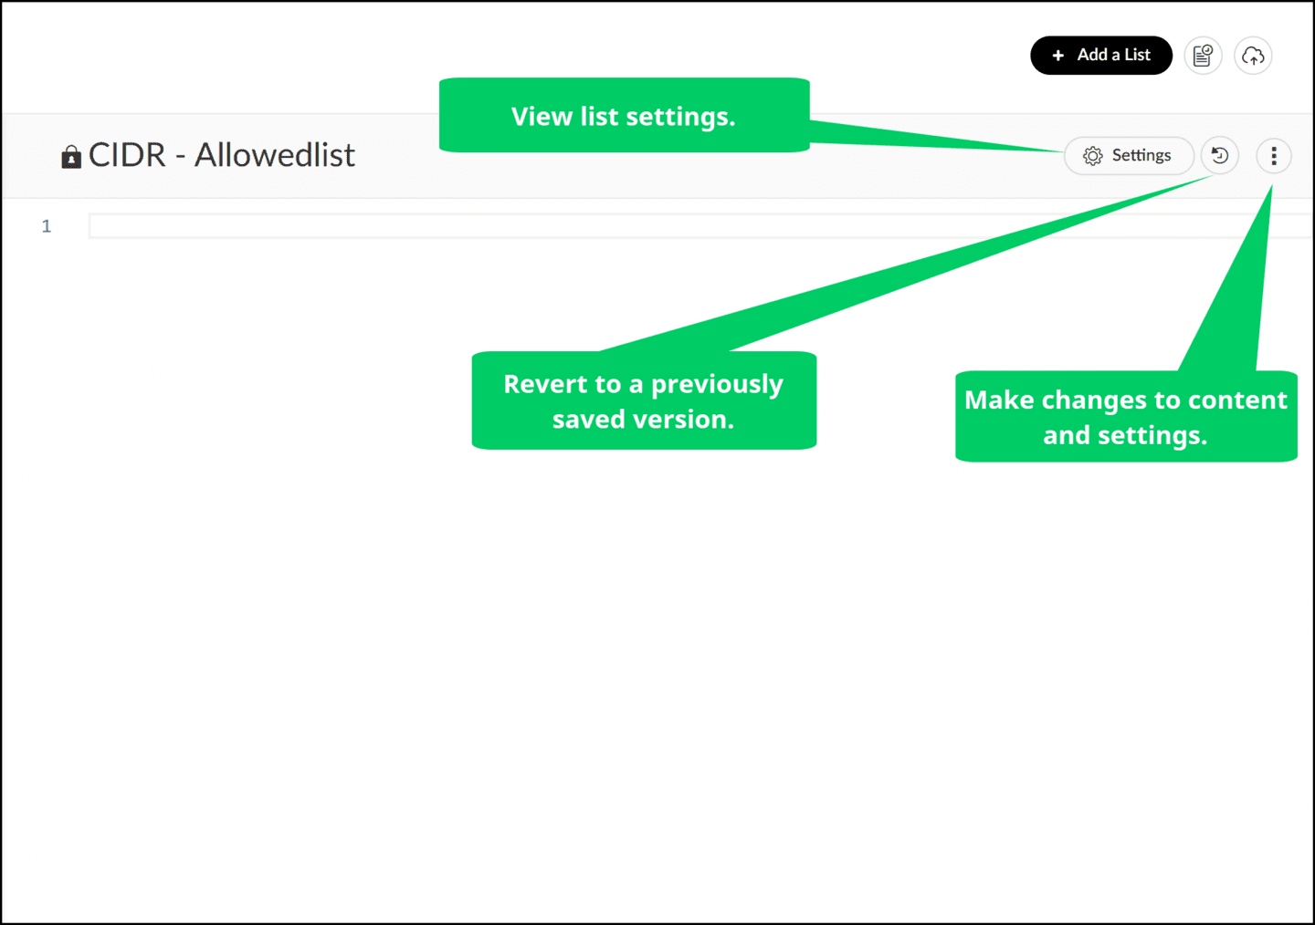

Duplicate, Download, or Delete a List
To duplicate, download, or delete the selected list, click the vertical ellipsis, and select Duplicate, Download, or Delete.
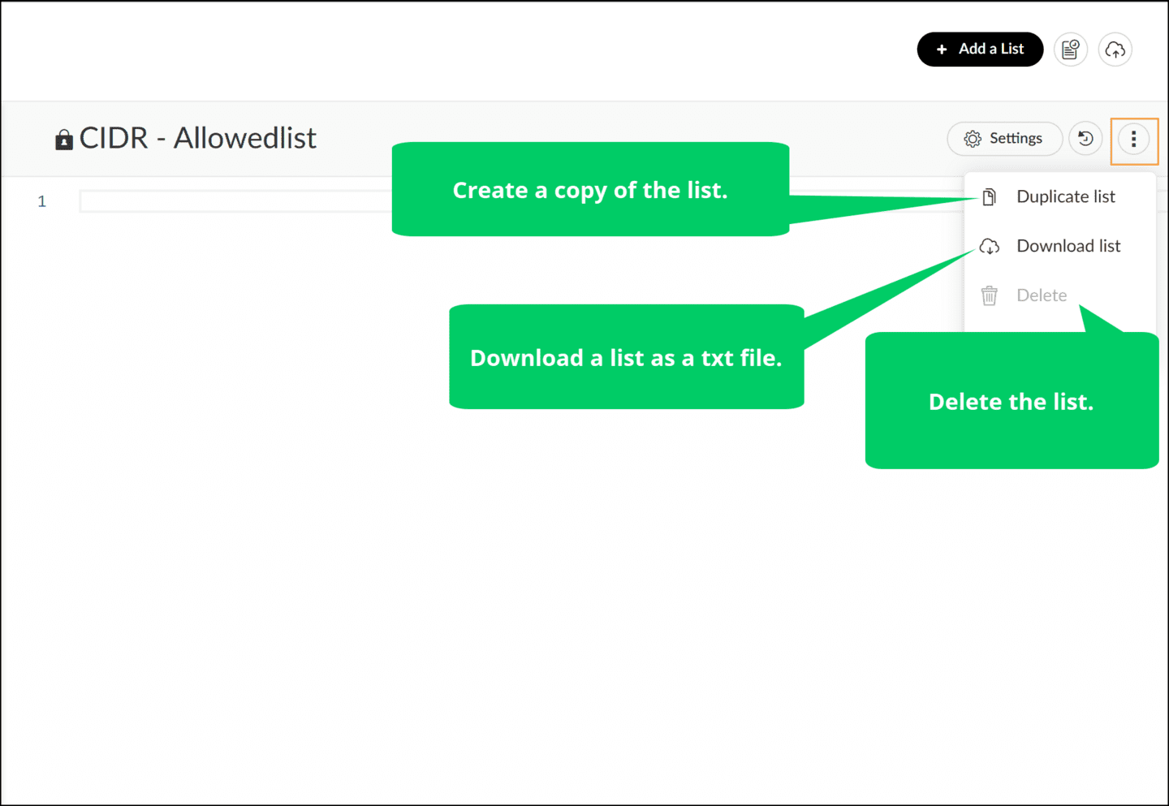

Demo: Creating and Managing Lists
Watch this demonstration on creating a list in Cortex and using the various options on the Lists page.

